Department of Computer Engineering
St. Francis Institute of Technology
University of Mumbai
2026-2027



A Mini-Project Report On

“FoodFlow: Peak Demand Zone Detection and Delivery Time Prediction for Indian Food Delivery using Apache Spark, HDFS and Streamlit”

Subject - Big Data Analysis

Under the guidance of
Ms. Monalisa Lopes

By
Aditya Nair (25, 232110)
Arya Patil (27, 232117)
Siddhi Trivedi(38, 232170)
TABLE OF CONTENTS
Abstract i
List of abbreviations ii
List of tables iii
List of figures iii
Chapter 1: Introduction 1
1.1 Introduction 1
1.2 Problem definition 1
1.3 Objectives 1
Chapter 2: Proposed work / methodology 2
2.1 System architecture 2
2.2 Data preprocessing 2
2.3 Models 3
2.4 Algorithms 3
Chapter 3: Experimental setup 4
3.1 Dataset description 4
3.2 Distributed storage (HDFS) 5
3.3 Tools 5
3.4 Libraries and frameworks 6
Chapter 4: Implementation 6
4.1 Backend implementation 6
4.2 Important functions 6
4.3 Streamlit dashboard 10
Chapter 5: Results 11
5.1 Results 11
5.2 Discussion 14
5.3 Limitations 14
Chapter 6: Conclusion 15
Chapter 7: References 15

Abstract
Food delivery platforms generate large volumes of order, traffic, weather and delivery-partner data every day. Two questions matter most to operations teams: where and when does demand peak, and how long will an order take to reach the customer. FoodFlow is a data-engineering and machine-learning project that answers both questions on Indian food delivery data using Apache Spark. The delivery dataset is stored on the Hadoop Distributed File System (HDFS) and read into Spark, where it is cleaned and enriched with derived features such as peak-hour and distance-bucket indicators. PySpark SQL aggregates orders by city zone and hour of day to detect peak demand zones, while PySpark MLlib trains a Random Forest regression pipeline to predict delivery time in minutes from distance, traffic, weather, vehicle type, delivery-partner attributes and time features. A strict leakage guard ensures that the target variable is never used as an input. The system was evaluated on 41,550 cleaned orders from a public Kaggle dataset of Indian cities, with an 80/20 train–test split. On 8,306 unseen test orders the model achieved a Mean Absolute Error of 3.77 minutes, a Root Mean Squared Error of 4.80 minutes and an R² of 0.737. Demand analysis showed that the evening window from 17:00 to 23:00 carries 72.3% of all orders, with Metropolitan evening hours forming the five busiest zone-hour cells. An interactive Streamlit dashboard presents these spatio-temporal trends as heatmaps together with delivery-time metrics and a prediction explorer.
Keywords: Apache Spark, HDFS, PySpark SQL, MLlib, Random Forest, delivery time prediction, demand heatmap, Streamlit

List of abbreviations
API – Application Programming Interface
CSV – Comma-Separated Values
DAG – Directed Acyclic Graph
EDA – Exploratory Data Analysis
HDFS – Hadoop Distributed File System
JSON – JavaScript Object Notation
JVM – Java Virtual Machine
MAE – Mean Absolute Error
ML – Machine Learning
MLlib – Spark Machine Learning Library
R² – Coefficient of Determination
RF – Random Forest
RMSE – Root Mean Squared Error
SQL – Structured Query Language
UI – User Interface

List of tables
Table 3.1: Dataset statistics 4
Table 3.2: Input features used by the model 5
Table 3.3: Libraries and frameworks used 6
Table 5.1: Peak demand zones detected by the Spark SQL query 12
Table 5.2: Model evaluation metrics on the held-out test set 13

List of figures
Figure 2.1: System architecture of FoodFlow 2
Figure 3.1: HDFS layout and Spark read 5
Figure 4.1: get_spark_session() function 6
Figure 4.2: clean_data() function 7
Figure 4.3: engineer_features() function 7
Figure 4.4: Peak demand zone query in Spark SQL 8
Figure 4.5: assert_no_leakage() function 8
Figure 4.6: build_pipeline() function 9
Figure 4.7: train_test_split() function 9
Figure 4.8: compute_metrics() function 10
Figure 4.9: _compute_eda_summary() function 10
Figure 5.1: Streamlit dashboard overview 11
Figure 5.2: Average delivery time by traffic level 11
Figure 5.3: Average delivery time by weather 11
Figure 5.4: Average delivery time by concurrent deliveries 12
Figure 5.5: Orders by hour of day 12
Figure 5.6: Peak demand zone heatmap (city zone × hour) 13
Figure 5.7: Demand heatmap (day of week × hour) 13
Figure 5.8: Actual versus predicted delivery time 14

Chapter 1: Introduction

1.1 Introduction
Online food delivery has become part of everyday life in Indian cities. Every order creates a record that includes the distance travelled, the traffic and weather on the route, the type of vehicle used, the delivery partner’s age and rating, and the time of day. When these records are collected over many cities and months, they grow too large and too varied for a single spreadsheet or a simple script to handle comfortably. Distributed data-processing platforms such as Apache Spark are built for this kind of workload [1], [2].
FoodFlow is a project that applies Apache Spark to Indian food delivery data. Spark processes the data in parallel, the Hadoop Distributed File System (HDFS) provides scalable storage [5], PySpark SQL [3] is used to find where and when demand peaks, and PySpark MLlib [4] is used to predict how long a delivery will take. The results are shown in an interactive Streamlit dashboard that helps a user explore demand patterns, delivery metrics and model predictions.

1.2 Problem definition
Delivery businesses need to plan riders and promise delivery times well before an order is completed. Two problems make this difficult. First, demand is not evenly spread: it concentrates in particular zones and hours, and riders placed outside these windows are wasted while riders placed inside them are overloaded. Second, delivery time depends on many interacting factors such as distance, traffic jams, bad weather and the number of orders a rider carries at once, so a single fixed estimate is often wrong. The problem addressed by this project is:
“To design and implement a Spark-based system that detects peak demand zones from large-scale Indian food delivery data and predicts delivery time accurately, and to present both results in an interactive dashboard.”

1.3 Objectives
- To process Indian food delivery data at scale using Apache Spark, with HDFS as the storage layer.
- To clean and validate the data by removing duplicates, imputing missing values and filtering physically implausible records.
- To use PySpark SQL to aggregate orders by zone and hour and detect peak demand zones.
- To engineer features such as peak-hour flags and distance buckets for the learning task.
- To train a PySpark MLlib Random Forest regression pipeline that predicts delivery time in minutes.
- To prevent target leakage by guaranteeing that delivery time is never part of the model input.
- To evaluate the model with MAE, RMSE and R² on a held-out test set.
- To build an interactive Streamlit dashboard showing demand heatmaps, delivery metrics and predictions.

Chapter 2: Proposed work / methodology

2.1 System architecture
FoodFlow follows a layered pipeline. A public food delivery dataset is converted into a common schema and stored on HDFS. A Spark session reads the data and performs cleaning and feature engineering. From the prepared data, two analyses run in parallel: PySpark SQL aggregates orders into zone-and-hour demand summaries to detect peak demand zones, and a PySpark MLlib pipeline trains and evaluates a delivery time model. Metrics, predictions and aggregated summaries are written to an output folder, which the Streamlit dashboard reads to draw charts and heatmaps. The dashboard never starts Spark itself, so it stays light and responsive.
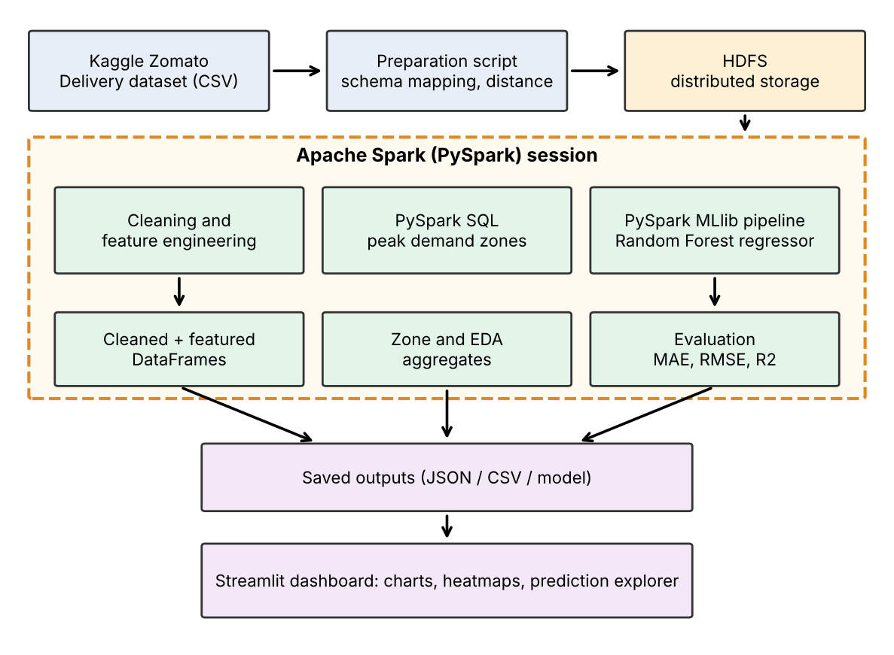
Figure 2.1 – System architecture of FoodFlow

2.2 Data preprocessing
Raw delivery records contain duplicates, missing ratings and a few impossible values. The preprocessing stage cleans them with Spark DataFrame operations so that the work is done in parallel rather than row by row in Python. The steps are:
- Schema validation – the dataset must contain every required column, otherwise the pipeline stops with a clear error.
- Duplicate removal – exact duplicate rows are dropped.
- Target validation – rows whose delivery time is missing or not positive are removed.
- Missing value imputation – missing delivery-partner ratings are replaced by the column median, estimated with approxQuantile.
- Outlier filtering – distances outside (0, 100] km, ratings outside [1, 5], partner ages outside [16, 70] years and delivery times outside [5, 180] minutes are treated as invalid and removed.
Before the data reaches Spark, a one-time preparation script maps the original Kaggle column names to the FoodFlow schema. It computes the distance between restaurant and delivery location with the haversine formula, corrects a known sign error in some latitude values, and parses two different time formats found in the order-time column. Rows that lack any required field are dropped; 41,550 of 45,584 raw rows (91%) remain.

2.3 Models

2.3.1 Distributed storage and processing
HDFS stores the dataset as blocks replicated across nodes, which gives fault tolerance and lets Spark read the data close to where it is stored [5]. Apache Spark keeps intermediate data in memory and plans every job as a directed acyclic graph of transformations, which makes iterative analysis much faster than classic MapReduce [1], [2]. FoodFlow uses a Spark session for loading, cleaning, aggregation and model training, and avoids collecting the full dataset to the driver: only small aggregated results are ever brought back.

2.3.2 Peak demand zone detection
The raw data is registered as a Spark SQL view, and a SQL query groups orders by city zone (Metropolitan, Urban, Semi-Urban) and hour of day. For every zone-hour cell it counts orders and averages delivery time. A window function, PERCENT_RANK, ranks the cells by order volume, and the cells in the top decile are reported as peak demand zones. Because the zone dimension is combined with the hour dimension, the result is a spatio-temporal demand matrix that can be drawn directly as a heatmap.

2.3.3 Delivery time prediction
Delivery time prediction is a regression task: given the attributes of an order, predict time_taken_min. The attributes include numeric features (distance, partner age, partner rating, concurrent deliveries, order hour, weekend and peak-hour flags) and categorical features (weather, traffic level, vehicle type, day of week, city type, order category and distance bucket). Categorical features are converted to numbers with StringIndexer and OneHotEncoder, and all features are combined into a single vector by VectorAssembler. These stages and the learning algorithm are chained into one MLlib Pipeline, so exactly the same transformations are applied during training and prediction [4].

2.4 Algorithms

2.4.1 Random Forest regression
A Random Forest builds many decision trees, each on a random sample of the training rows and a random subset of the features, and averages their predictions [6]. Averaging reduces the variance of individual trees, handles a mix of numeric and one-hot features without scaling, is robust to outliers and can capture interactions such as heavy traffic combined with long distance. FoodFlow uses 80 trees with a maximum depth of 8 and a fixed random seed of 42 so that results are reproducible.

2.4.2 Evaluation metrics
The model is evaluated on a held-out test set that makes up 20% of the data. Three metrics are computed with Spark’s RegressionEvaluator:
- MAE – the average absolute difference between predicted and actual delivery time, in minutes.
- RMSE – the square root of the mean squared error; it penalises large errors more strongly.
- R² – the share of the variance in delivery time explained by the model; a value of 1 is a perfect fit.

Chapter 3: Experimental setup

3.1 Dataset description
The project uses the public Kaggle dataset “Zomato Delivery Operations Analytics”, which records food deliveries in Indian cities together with delivery-partner details, weather, road traffic and delivery time. It is a static, published dataset and is not live production data of any company. After conversion to the FoodFlow schema and cleaning it contains 41,550 orders and 14 columns, stored in CSV format. The city-type value is spelled “Metropolitian” in the source data; it is reproduced as “Metropolitan” in the tables and figures of this report.
Property | Value
Source | Kaggle – Zomato Delivery Operations Analytics
Raw records | 45,584
Records after cleaning | 41,550 (91%)
Format | CSV
Columns | 14 (13 inputs + 1 target)
Target | time_taken_min (minutes)
Average delivery time | 26.48 min (min 10, max 54)
Average distance | 9.76 km
City types | Metropolitan 31,920; Urban 9,478; Semi-Urban 152
Weather classes | Fog, Stormy, Cloudy, Sandstorms, Windy, Sunny
Traffic levels | Low, Medium, High, Jam
Vehicle types | Motorcycle, Scooter, Electric scooter

Table 3.1: Dataset statistics
Table 3.2 lists the 14 input features given to the model. Order identifiers and the target are never used as inputs.
Type | Features
Numeric (7) | distance_km, delivery_person_age, delivery_person_ratings, multiple_deliveries, order_hour, is_weekend, is_peak_hour
Categorical (7) | weather, traffic_level, vehicle_type, day_of_week, city_type, restaurant_category (order type), distance_bucket
Target | time_taken_min (excluded from the inputs)

Table 3.2: Input features used by the model

3.2 Distributed storage (HDFS)
The prepared dataset is stored in a project directory on HDFS with separate folders for raw data, processed data and outputs. Spark reads files through an hdfs:// address and registers the resulting DataFrame as a SQL view called deliveries so that it can be queried with PySpark SQL. All locations used by the pipeline are defined in one configuration module, so the same code can run against the local file system during development and against HDFS in the cluster setting.
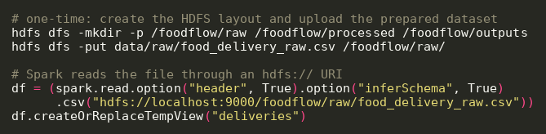
Figure 3.1 – HDFS layout and Spark read

3.3 Tools
- Python 3.12: used for the whole data and machine-learning pipeline.
- Apache Spark (PySpark) 4.2: distributed data processing, PySpark SQL and MLlib.
- HDFS: distributed storage of the dataset.
- OpenJDK 21: Java runtime required by Spark.
- Streamlit: interactive dashboard.
- Visual Studio Code: source code editing.
- Git and GitHub: version control.
- pytest: unit tests for configuration paths and the leakage guard.

3.4 Libraries and frameworks
Library / Framework | Purpose
pyspark 4.2.0 | Spark session, DataFrame, SQL and MLlib
pandas 3.0.2 | One-time dataset preparation and dashboard tables
numpy 2.4.4 | Numerical operations and haversine distance
streamlit 1.64.0 | Interactive dashboard
plotly 7.1.0 | Charts and heatmaps in the dashboard
pytest 9.1.1 | Automated tests

Table 3.3: Libraries and frameworks used

Chapter 4: Implementation

4.1 Backend implementation
The backend is a Python package organised into small modules, each with one responsibility: config.py (paths, schema and hyper-parameters), data_loader.py (Spark session and loading), preprocessing.py (cleaning), feature_engineering.py (derived features and the leakage guard), ml_model.py (MLlib pipeline), evaluation.py (metrics) and pipeline.py (orchestration). A single command, python run_pipeline.py, runs the complete workflow: load, clean, summarise, engineer features, split, train, predict, evaluate and save. The Spark session is created inside the pipeline and stopped when it ends, and failures are written to a status file so that the dashboard can report them instead of crashing.

4.2 Important functions

4.2.1 get_spark_session() — Spark session
File: src/data_loader.py
This function builds the Spark session used by the whole pipeline. It sets the application name, the master, the number of shuffle partitions and the driver memory. Four shuffle partitions are enough for this data size and avoid the overhead of Spark’s default of 200.
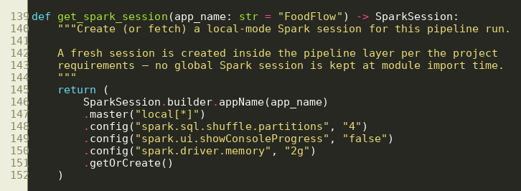
Figure 4.1 – get_spark_session() function

4.2.2 clean_data() — Data cleaning
File: src/preprocessing.py
The function removes duplicates, drops rows with an invalid target, fills missing ratings with the median and filters implausible values. Everything is expressed with DataFrame operations, and the row counts before and after cleaning are logged. The excerpt shows the median imputation and the validity filter.
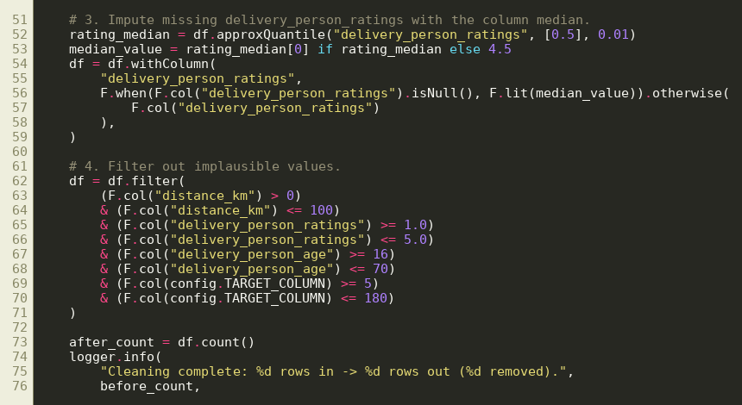
Figure 4.2 – clean_data() function

4.2.3 engineer_features() — Feature engineering
File: src/feature_engineering.py
Two features are derived with Spark expressions. is_peak_hour marks orders placed in lunch and dinner rush windows, and distance_bucket groups distance into short, medium, long and very long classes.
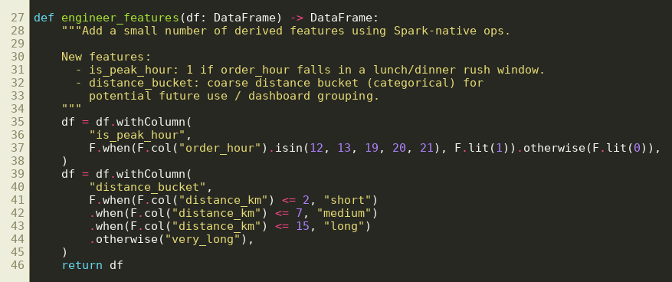
Figure 4.3 – engineer_features() function

4.2.4 Peak demand zone query — PySpark SQL
File: Spark SQL query run through spark.sql() on the deliveries view
The query first builds a zone-hour table with the order count and the average delivery time for every combination of city zone and hour. It then ranks these cells with PERCENT_RANK and keeps those in the top 10% by order volume. The result is the list of peak demand zones and also the matrix used for the heatmap.
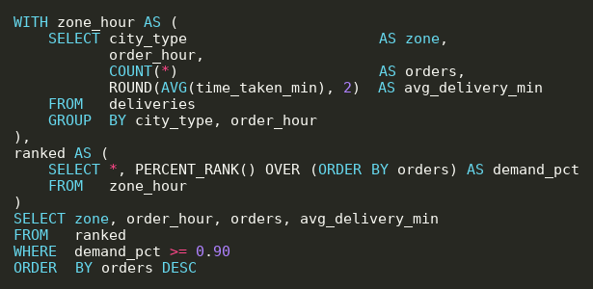
Figure 4.4 – Peak demand zone query in Spark SQL

4.2.5 assert_no_leakage() — Leakage guard
File: src/feature_engineering.py
Target leakage would make the model look accurate without being useful. This function checks the final feature list and raises an error if the delivery time column ever appears in it. It is called while the pipeline is being built, and a unit test confirms that it raises when it should.
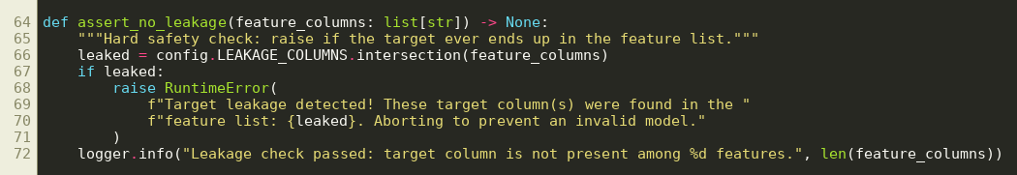
Figure 4.5 – assert_no_leakage() function

4.2.6 build_pipeline() — MLlib pipeline
File: src/ml_model.py
The function creates one StringIndexer and one OneHotEncoder for each categorical column, combines all numeric and encoded columns with VectorAssembler and appends a RandomForestRegressor. The stages are chained into a Pipeline, which is later fitted on the training data and saved as a single model.
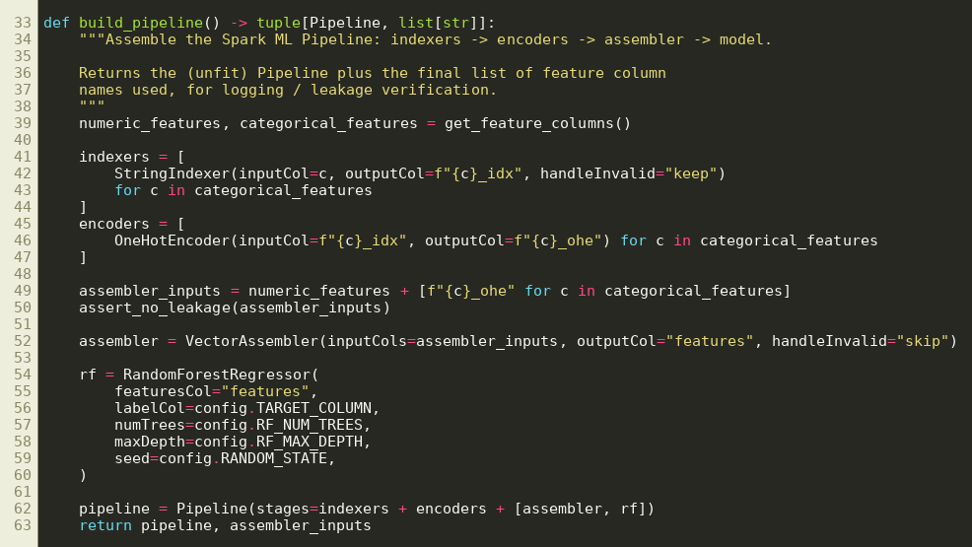
Figure 4.6 – build_pipeline() function

4.2.7 train_test_split() — Reproducible split
File: src/ml_model.py
The data is divided 80/20 with Spark’s randomSplit and a fixed seed, so every run produces the same training and test sets.
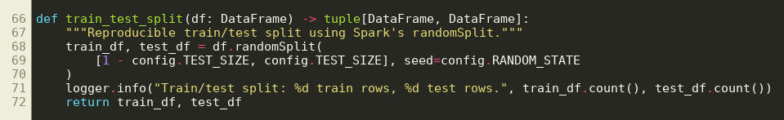
Figure 4.7 – train_test_split() function

4.2.8 compute_metrics() — Evaluation
File: src/evaluation.py
For each of RMSE, MAE and R² the function builds a RegressionEvaluator and evaluates the predictions on the test set. The values, the number of test rows and a time stamp are saved to metrics.json, so every number shown in the dashboard comes from an actual run.
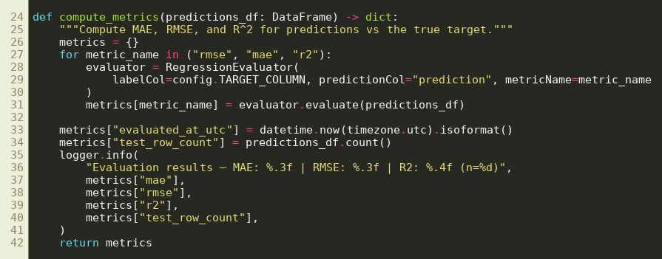
Figure 4.8 – compute_metrics() function

4.2.9 _compute_eda_summary() — Aggregated statistics
File: src/pipeline.py
Summary statistics are computed inside Spark with groupBy and agg. Only the small aggregated result, a single row or a few rows per category, is collected to the driver, never the raw dataset.
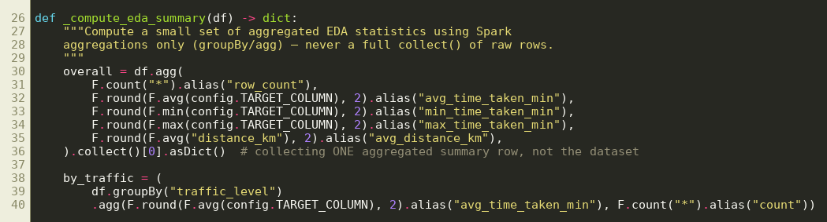
Figure 4.9 – _compute_eda_summary() function

4.3 Streamlit dashboard
The dashboard (dashboard/app.py) reads the files produced by the pipeline and does not start Spark. Its sections are:
- Project overview: what FoodFlow does and how the pipeline works.
- Dataset summary: number of orders, average delivery time and distance, and a preview of the cleaned data.
- Spatio-temporal heatmaps: order volume by city zone and hour, and by day of week and hour, so that peak demand zones are visible at a glance.
- Delivery metrics: delivery time by traffic level, weather and vehicle type, and delivery time against distance.
- Model performance: MAE, RMSE, R² and an actual-versus-predicted plot.
- Prediction explorer: a sortable, filterable table of test predictions with the absolute error of each order.

Chapter 5: Results

5.1 Results
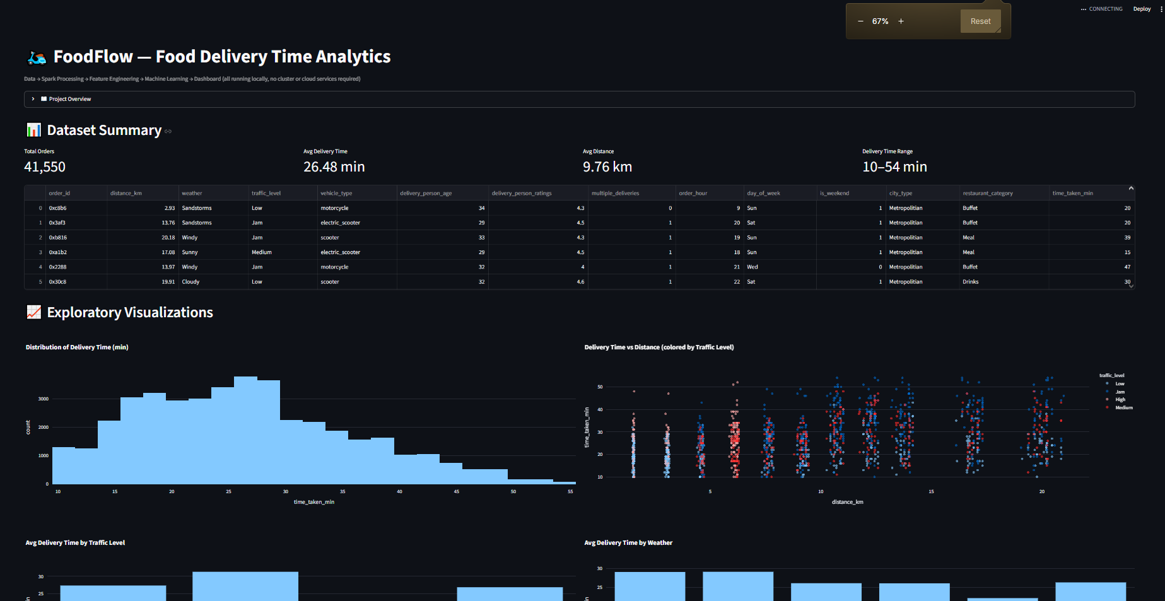

Figure 5.1 – Streamlit dashboard overview
Delivery metrics. Traffic has the clearest effect on delivery time. Orders in a traffic jam take 31.34 minutes on average, against 21.41 minutes in low traffic. Weather matters too: sunny days average 22.03 minutes, while fog and cloudy conditions average about 29 minutes. The number of orders a rider carries at once has the strongest effect of all, with delivery time rising from 22.99 minutes for a single order to 47.83 minutes for three concurrent deliveries.
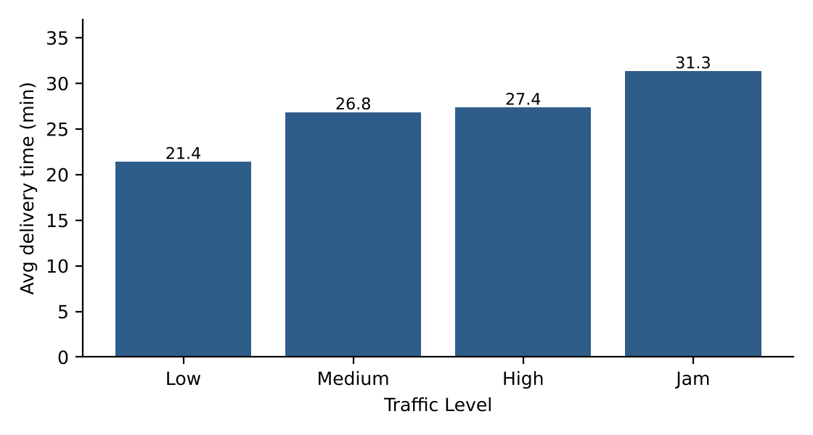
Figure 5.2 – Average delivery time by traffic level
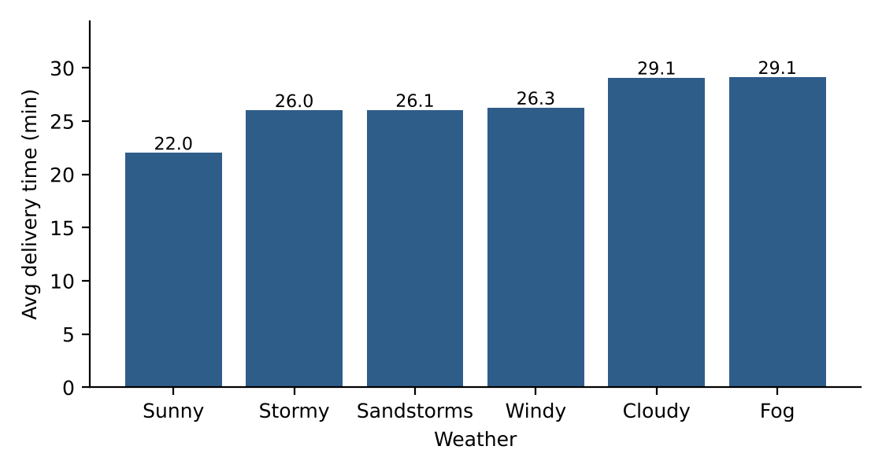
Figure 5.3 – Average delivery time by weather
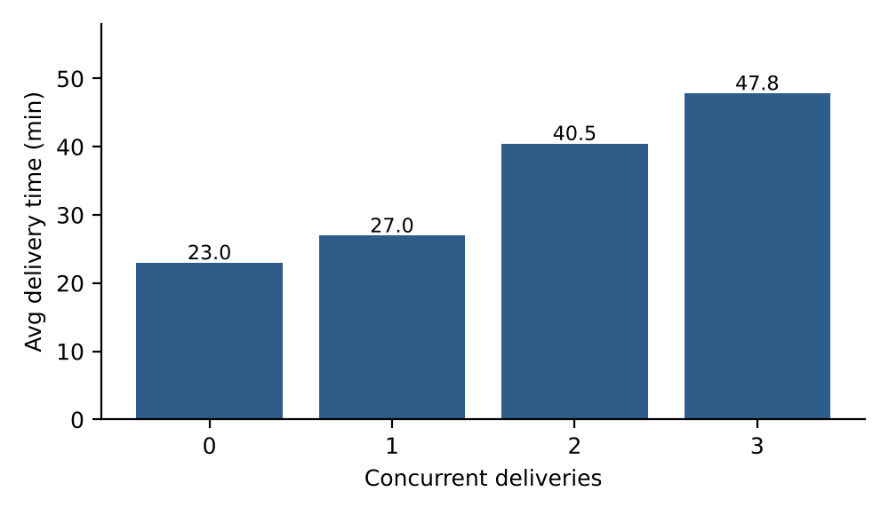
Figure 5.4 – Average delivery time by concurrent deliveries
Demand analysis. Order volume is strongly concentrated in the evening. The hours from 17:00 to 23:00 each carry more than 1.5 times the average hourly volume of 1,731 orders, and together they account for 72.3% of all orders. Orders in this window also take longer, 27.86 minutes on average against 22.89 minutes for the rest of the day.
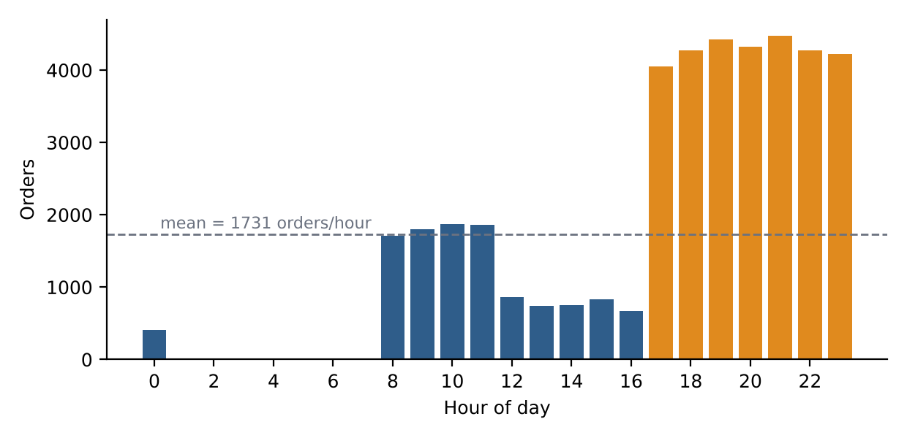
Figure 5.5 – Orders by hour of day
Peak demand zones. Table 5.1 lists the zone-hour cells selected by the Spark SQL query, which are the top decile by order volume. All five belong to the Metropolitan zone between 17:00 and 21:00. The busiest cell, Metropolitan at 21:00, received 3,589 orders with an average delivery time of 31.91 minutes.
Rank | Zone | Hour | Orders | Avg delivery time (min)
1 | Metropolitan | 21:00 | 3,589 | 31.91
2 | Metropolitan | 19:00 | 3,578 | 31.49
3 | Metropolitan | 20:00 | 3,439 | 32.03
4 | Metropolitan | 18:00 | 3,356 | 28.17
5 | Metropolitan | 17:00 | 3,201 | 28.36

Table 5.1: Peak demand zones detected by the Spark SQL query
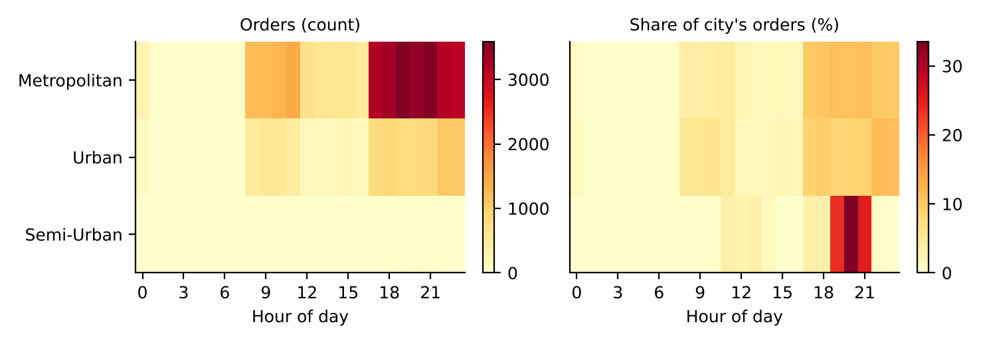
Figure 5.6 – Peak demand zone heatmap (city zone × hour)
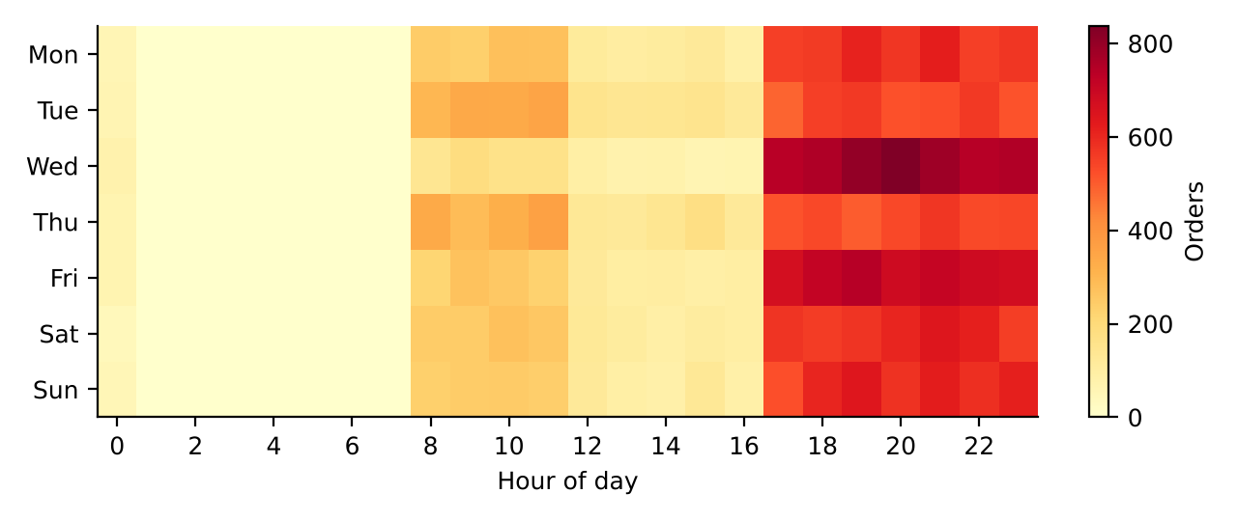
Figure 5.7 – Demand heatmap (day of week × hour)
Delivery time prediction. On the 8,306 test orders that the model had never seen, the Random Forest pipeline reached an MAE of 3.77 minutes, an RMSE of 4.80 minutes and an R² of 0.737 (Table 5.2). The model was trained on 33,244 orders. Since the average delivery time is 26.48 minutes, a typical error of under four minutes is about 14% of the average.
Metric | Value | Meaning
MAE | 3.77 min | Average absolute error
RMSE | 4.80 min | Error that penalises large misses
R² | 0.737 | Share of variance explained
Test orders | 8,306 | 20% hold-out
Training orders | 33,244 | 80% of the cleaned data
Table 5.2: Model evaluation metrics on the held-out test set
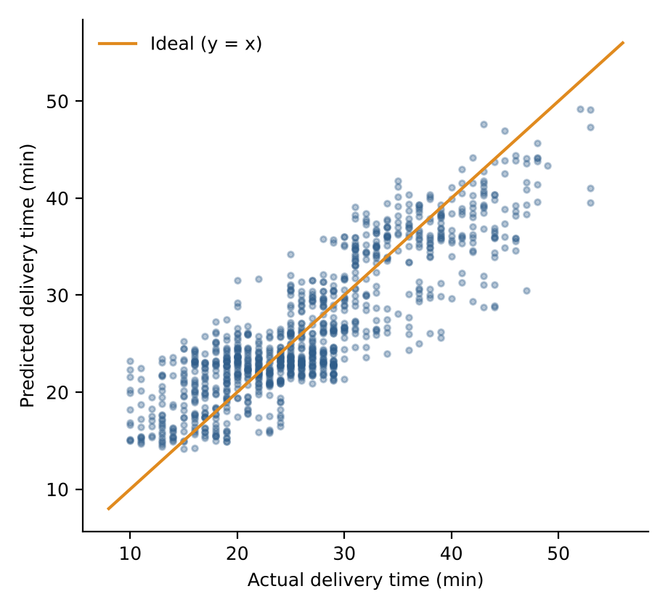
Figure 5.8 – Actual versus predicted delivery time (sample of 1,000 test orders)

5.2 Discussion
The results show that the pipeline answers both operational questions. The demand analysis points to a clear rule: the evening hours in Metropolitan areas are where riders are needed most, and they are also the hours in which deliveries are slowest, so the busiest zones are also the most stressed. The prediction model explains almost three quarters of the variation in delivery time with an average error of under four minutes, and the actual-versus-predicted plot follows the ideal diagonal closely.
Two details are worth noting. The is_peak_hour feature used by the model marks the conventional lunch and dinner windows (12–13 and 19–21), whereas the demand query shows that in this dataset the entire 17:00–23:00 period is busy and midday is quiet. Because order_hour is also a model input, the model can learn the true pattern on its own, but a feature based on the detected peak window could be tried. Also, the Semi-Urban zone has only 152 orders, so its average delivery time of 49.71 minutes should be read with caution.

5.3 Limitations
- The experiments were run in Spark local mode on a single machine. Multi-node HDFS deployment and scalability tests on much larger data volumes were not carried out.
- The dataset is a static public dataset of about 41,000 orders and does not stream live data; the dashboard shows the results of the last pipeline run.
- Zones are the three city categories in the data, not neighbourhoods. The heatmaps are therefore zone-by-hour grids; latitude and longitude are used only to compute distance and are not retained, so a geographic map overlay is not yet available.
- The Semi-Urban zone has very few records, which limits conclusions for that zone.
- Only a Random Forest model with fixed hyper-parameters was trained; no hyper-parameter search or comparison with other algorithms was performed.
- The order category is a stand-in taken from the order type field (Snack, Meal, Drinks, Buffet), because the source data has no restaurant category.

Chapter 6: Conclusion
FoodFlow demonstrates an end-to-end Spark workflow for Indian food delivery data. Data stored on HDFS is read into Spark, cleaned, enriched with features, analysed with PySpark SQL to detect peak demand zones, and used to train a PySpark MLlib Random Forest that predicts delivery time with an MAE of 3.77 minutes and an R² of 0.737 on unseen orders. The analysis shows that 72.3% of orders arrive between 17:00 and 23:00 and that the five busiest zone-hour cells are all in the Metropolitan zone in the evening. A strict leakage guard, a fixed random seed and metrics saved from real runs make the results reproducible and trustworthy. The Streamlit dashboard brings the demand heatmaps, delivery metrics and predictions together for easy exploration.
Possible improvements include retaining latitude and longitude so that demand can be drawn on real city maps, running the pipeline on a multi-node Spark and HDFS cluster with much larger data, comparing gradient-boosted trees and linear baselines with cross-validated hyper-parameter tuning, using weather and traffic feeds in real time with Spark Structured Streaming, and adding a rider-allocation recommendation based on the detected peak zones.

Chapter 7: References
[1] M. Zaharia, M. Chowdhury, M. J. Franklin, S. Shenker and I. Stoica, “Spark: Cluster computing with working sets,” in Proc. 2nd USENIX Workshop on Hot Topics in Cloud Computing (HotCloud), 2010.
[2] M. Zaharia et al., “Resilient distributed datasets: A fault-tolerant abstraction for in-memory cluster computing,” in Proc. 9th USENIX Symp. Networked Systems Design and Implementation (NSDI), 2012, pp. 15–28.
[3] M. Armbrust et al., “Spark SQL: Relational data processing in Spark,” in Proc. ACM SIGMOD Int. Conf. Management of Data, 2015, pp. 1383–1394.
[4] X. Meng et al., “MLlib: Machine learning in Apache Spark,” J. Machine Learning Research, vol. 17, no. 34, pp. 1–7, 2016.
[5] K. Shvachko, H. Kuang, S. Radia and R. Chansler, “The Hadoop distributed file system,” in Proc. IEEE 26th Symp. Mass Storage Systems and Technologies (MSST), 2010, pp. 1–10.
[6] L. Breiman, “Random forests,” Machine Learning, vol. 45, no. 1, pp. 5–32, 2001.
[7] B. Chambers and M. Zaharia, Spark: The Definitive Guide. Sebastopol, CA, USA: O’Reilly Media, 2018.
[8] Apache Software Foundation, “Apache Spark documentation.” [Online]. Available: https://spark.apache.org/docs/latest/
[9] Apache Software Foundation, “HDFS architecture guide.” [Online]. Available: https://hadoop.apache.org/docs/stable/hadoop-project-dist/hadoop-hdfs/HdfsDesign.html
[10] Streamlit Inc., “Streamlit documentation.” [Online]. Available: https://docs.streamlit.io/
[11] “Zomato Delivery Operations Analytics Dataset,” Kaggle. [Online]. Available: https://www.kaggle.com/

